

END OF TERM 2
AGRICULTURE STD 5
2022
NORTH EAST REGION

Section A
Answer all the given questions correctly.
3.1.1.1
1. Explain the following terms
a) Agriculture _______________________________________________ (1mark)
__________________________________________________________________
2.3.1.3
b) Germination_________________________________________________(1mark)
__________________________________________________________________
1.4.1.1
c) Fertilizers
(1mark)
2.3.1.4
2. Name any two examples of inorganic fertilizers.
a)________________________________________
b)________________________________________(2 marks)
3.1.1.2
3. List any three requirements of plant growth
a)_________________________________________________
b)_________________________________________________
c)_________________________________________________ (3 marks)

The diagrams below labelled U and V show farm tools. Use them to answer question 4.

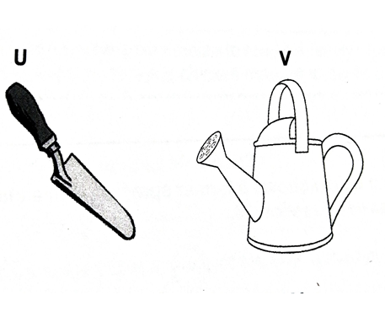

4. a) State one use of each of the tools labelled U and V
U_________________________________________________________
V_________________________________________________________(2 marks)
b) Give two ways of protecting the tool labelled U
- _____________________________________________________________

- _____________________________________________________(2 marks)

c) State one proper way of storing tool labelled V
i)_________________________________________________________ (1 mark)

2.3.1.7
5. Study the diagrams below carefully to answer question 5 (2 marks)
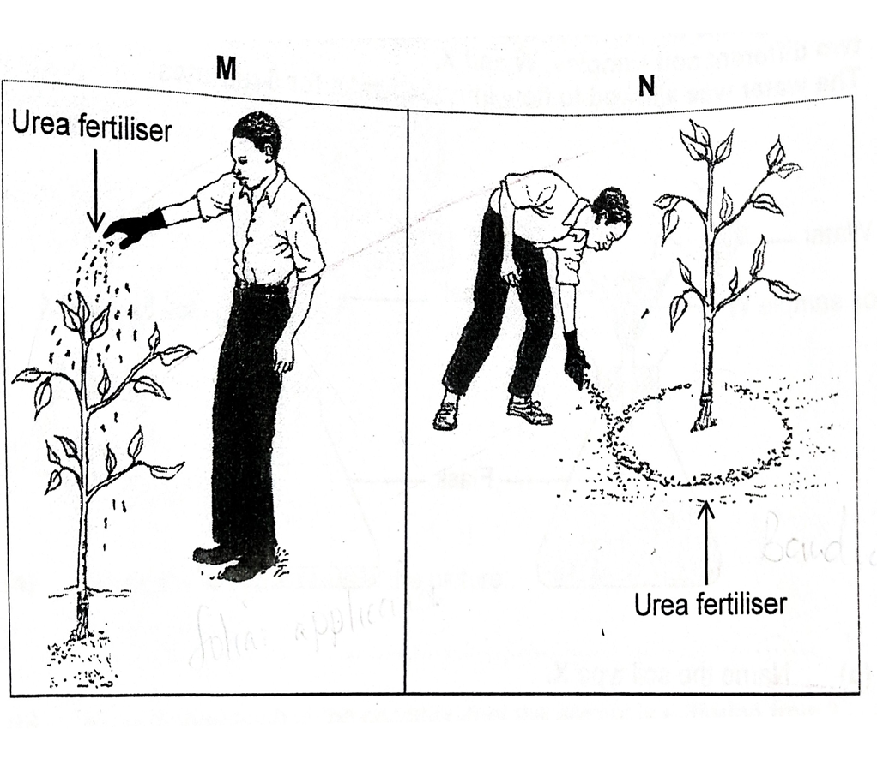
In which of the diagrams was the fertilizer applied correctly? (1 mark)
- ______________________________________________________

b. State one reason for your answer (1 mark)
_________________________________________________________

1.1.1.7
Use the information below to answer question 6

Peter: I want to produce maize but I do not know how to do it.
John: Producing maize is very easy. I have done that for 25 years but my problem is that I do not have enough money to expand my business.

6. What advice can you give to both farmers to help them solve their problems?
(2 marks)

FARMER | ADVICE
Peter
John

3.1.1.2
The diagram below shows a bean seed. Use it to answer question 12

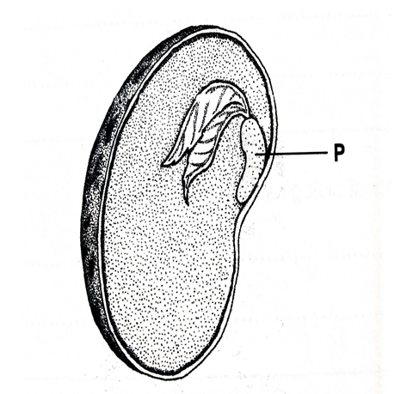

7. State two factors that are needed for the growth of the part labelled P
i) ___________________________________________________________
ii) _________________________________________________________
( 2 marks)

SECTION B
2.1.12
8.State two agents of physical weathering
i) ________________________________________________________________
ii) ____________________________________________________________
(2 marks)
Read the information below and use it to answer question 8.
2.3.1.3
Mr. Motse has a field where he grows maize to feed his family. Each year before the ploughing season, he adds chicken manure to his field.

9.a) Which type of fertilizer is used by Mr. Motse? ______________________________________________________________ 1mark
b) State the other type of fertilizer apart from the one named in (a)
____________________________________________________ 1mark
c) State three ways in which addition of chicken manure helps to improve the soil in Mr. Motse’s field.
- ___________________________________________________________
- ___________________________________________________________
- ___________________________________________________ 3 marks

2.3.1.5

10. Give two advantages of organic fertilizers

a) ________________________________________________________

b) ______________________________________________________
2 marks

The diagram below shows an example of how weathering takes place. Use it to answer 12.
2.1.1.1

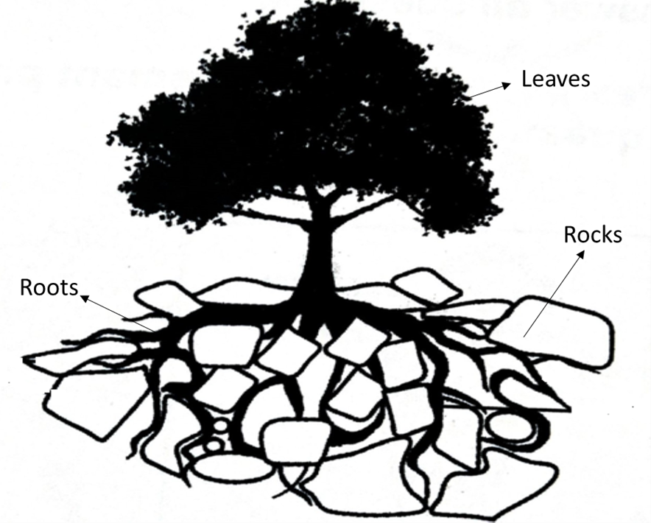

11. a) Name the type of weathering shown in the picture above ____________________________________________________________ 1 mark
b) Describe what is happening in this type of weathering _____________________________________________________________________________________________________________________________2 marks

1.4.1.1
12. Describe the processes of biotechnology
i) Traditional biotechnology
_____________________________________________________________________________________________________________________________2 marks
ii) Modern biotechnology
_____________________________________________________________________________________________________________________________2 marks
b) In which type of biotechnology can we make sour milk?
____________________________________________________________ 1 mark
2.2.1.2
A student put soil in a bottle and heat it up with a burner. He observed that water droplets were formed at top of the lid of the bottle.
13. a) what is he investigating?
_____________________________________________________________1mark
b) What is the percentage of the soil constituent investigated?
_______________________________________________________________ 1mark

2.3.1.3
Ms. Faith is using a kraal manure in her farm to improve soil fertility and her vegetables flourish.

14. a) what type of fertilizers is kraal manure?
____________________________________________________________ 1 mark
b) State one advantage of using kraal manure?
____________________________________________________________1 mark

MARKING GUIDE STD 5

1.a) Agriculture is the growing of crops and animals that are useful to us.
b) Germination is the development of an embryo from a seed into a seedling
c) Fertilizers are substances or materials that are added into the soil to add nutrients.
2. Urea, LAN, N.P.K Super phosphate etc
3. Nutrients, water, sunlight, absence of harmful factors e.t.c
4. Y – Transplanting seedlings
Z- Watering the plants
b i) Store in a secured place
ii) Wash after use
c) Keep it in a storeroom
5. a) Diagram N
b) The fertilizer is being applied directly to where the farmer wants it.
6. Peter – Consult with Agricultural demonstrators
John - Seek help from CEDA, NDB
7. Water, suitable temperature, air
8. Temperature, water, wind
9. a. Organic fertilizer
b. Inorganic fertilizers
c. i. It improves aeration
ii. It improves water holding capacity
iii It improves the texture of the soil
10. – it is cheap
- Improves soil structure
- It is easy to apply

11. a) Biological weathering
b) As the plant grows, the roots of the plant pushes the rocks causing them to break apart into small particles that eventually form soil.
12. i) Traditional – The traditional techniques of using living organisms to make new products for human use.
ii) Modern – Using modern techniques of using living organisms to make new products for human use.
b) Traditional biotechnology
13. a) Presence of moisture/water in the soil
b) 25%
14. a) -Organic fertilizer
b) It is cheap
- It improves soil structure
- It is easy to apply

